**INDIA’S AGRICULTURAL CROP PRODUCTION ANALYSIS (1997-2021)**

**BACHELOR OF SCIENCE IN MATHEMATICS**

**TEAM ID : NM2023TMID35639**

**TEAM LEAD : Ms. A.B. RITHANISHREE**

**TEAM MEMBER :**

**Ms. M. NITHYASRI**

**Ms. T. RANJANI**

**Mrs. P. REVATHI**

*Under the guidance of*

**Ms. S. MOHANA PRIYA., M.Sc., M.Phil.,**

Assistant Professor, Department of Mathematics



**DEPARTMENT OF MATHEMATICS**

**KSR COLLEGE OF ARTS AND SCIENCE FOR WOMEN**

**TIRUCHENGODE-637215**

**NAMAKKAL(DT), TAMIL NADU.**

**India’s Agricultural Crop Production Analysis (1997-2021)**

# **1.Introduction**

# **1.1 Overview**

This report delves into the captivating realm of India's agricultural cultivation, providing a comprehensive visual exploration of key aspects and trends in the agricultural sector. Through the visual representations, readers can gain valuable insights into crop production, seasonal variations, regional distribution, and overall production trends. These visualizations enable intuitive analysis, allowing stakeholders to uncover patterns, identify areas of growth or concern, and make data-driven decisions.

By harnessing the power of Tableau, this report not only presents the data in a visually appealing manner but also provides an interactive experience for readers to explore the intricacies of India's agricultural cultivation. To Extract the Insights from the data and put the data in the form of visualizations, Dashboards and Story we employed Tableau tool.

**1.2 Purpose**

Crop production is one of the fundamental branches of agriculture. Crop production is the basis for providing the livestock industry with feed, and the population with food. Also, crop products are used in many industries as raw materials of plant origin, such as food, textile, pharmaceutical, fuel and others.

# **2.Problem Definition and Design Thinking**

**2.1 Empathy Map**

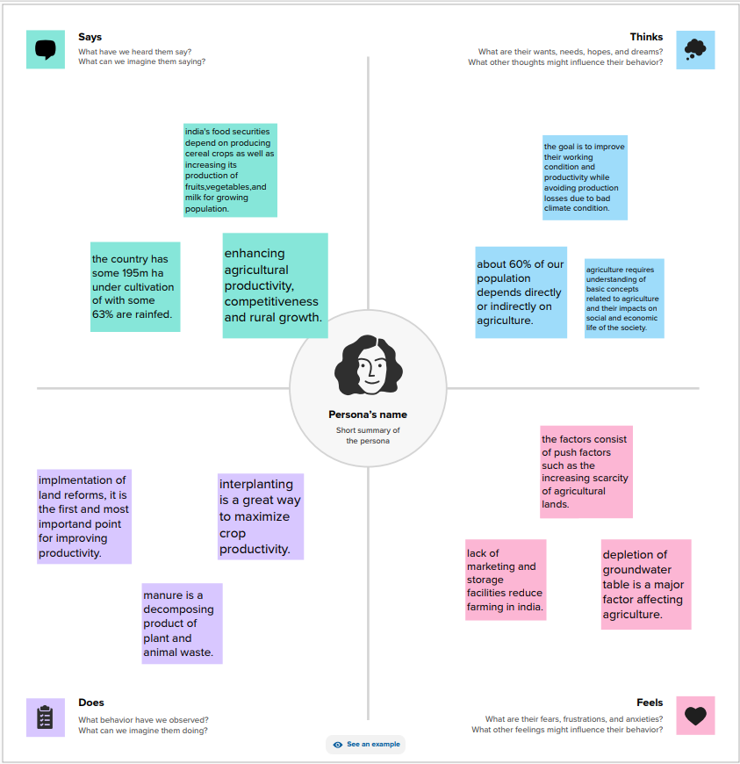

**2.2 Ideation and Brainstorming Map**

A mind map is a visualization technique and brainstorming tool which allows you to explore a central idea, and all of its related topics, in a non-linear way. When brainstorming, or attempting to see a particular topic from all angles, linear tools like lists aren't always the best solution.

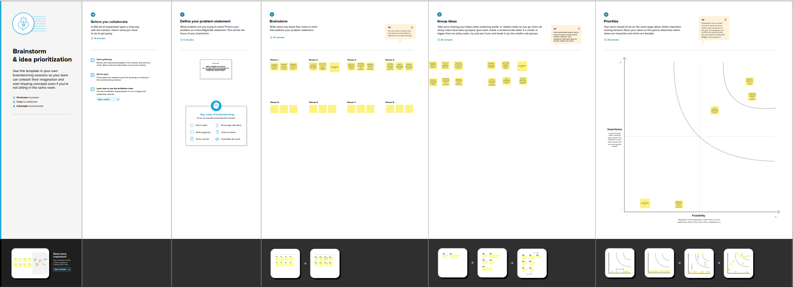

# **3.Result**

**3.1 State wise Agricultural Land**

Crop production is concentrated in Uttar Pradesh and the Maharashtra. The three states with the highest value of crop sales are in Uttar Pradesh and the Maharashtra, Punjab. Uttar Pradesh is India's top farming state, with considerable state-level crop production including bajra, rice, sugarcane, food grains, and many others.

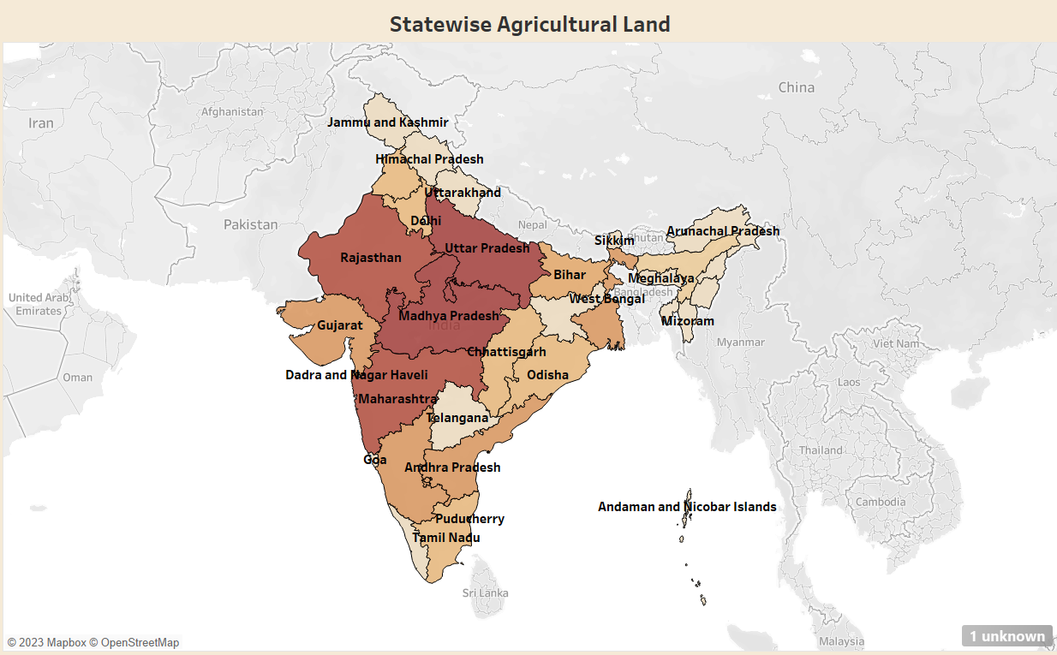

**3.2 Area vs Production**

Production Area means a surface area within any Development Area for the purpose of the performance of the Production Operations within the said Development Area.

Total area sown under Rabi crops has increased by 3.25% from 697.98 lakh hectares in 2021-22 to 720.68 lakh hectares in 2022-23. This is 22.71 lakh hectares more this year compared to corresponding period of 2021-22.

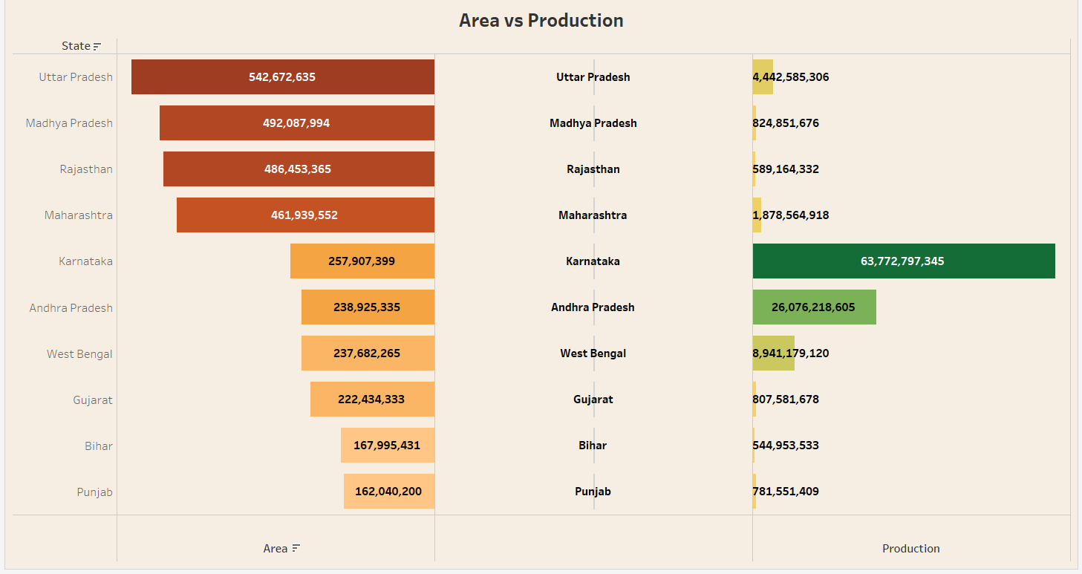

**3.3 Season Based Cultivation by Area**

There are three distinct crop seasons in India, namely Kharif, Rabi and Zaid. The Kharif season started with Southwest Monsoon under which the cultivation of tropical crops such as rice, cotton, jute, jowar, bajra and tur are cultivated.

Also known as monsoon crops, Kharif crops are sown at the start of the monsoon season and harvested at the end of the same. Typically, this period ranges from May to October, give or take a month or so, depending on the crop. Maize, rice, sugarcane, cotton, groundnut, and turmeric are a few examples of Kharif crops.

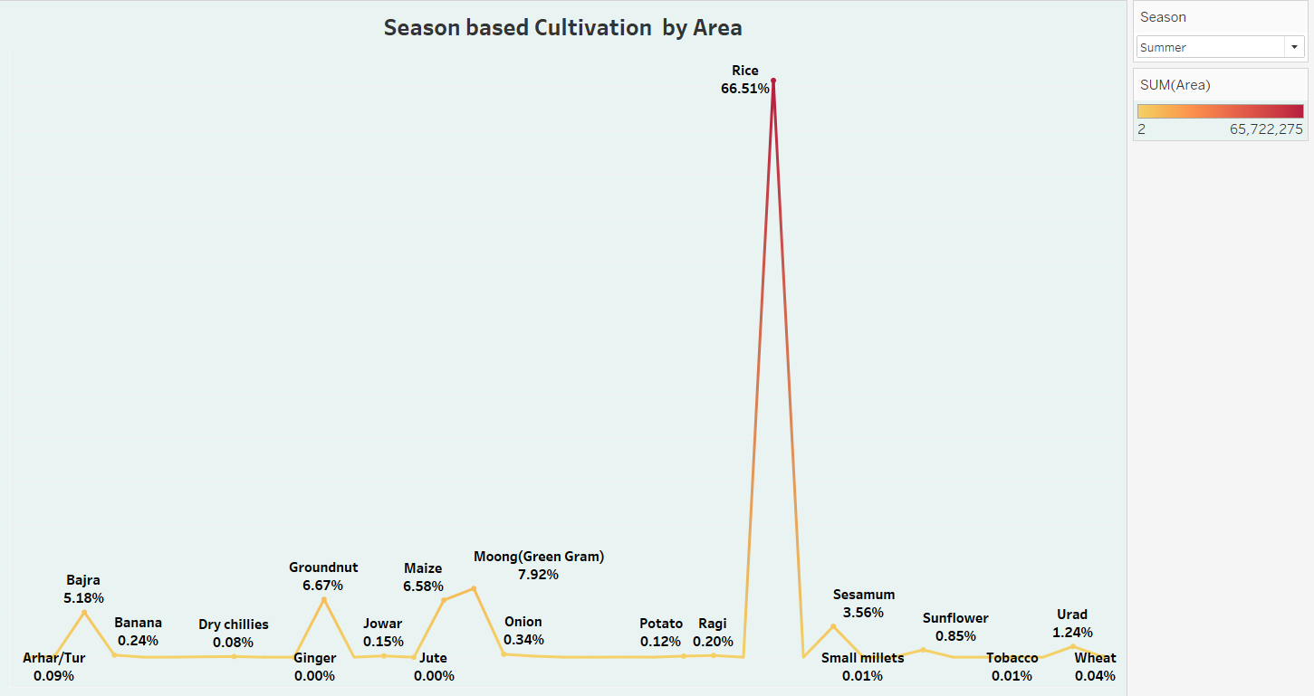

**3.4 Yield by Season**

Crop yields are the harvested production per unit of harvested area for crop products. The Kharif farming seasons is from July –October during the south-west monsoon and the Rabi farming seasons is from October-March (winter). The crops grown between March and June are summer crops. Wheat is a Rabi crop which requires 50-75 cm of rainfall annually and requires a short cool season.

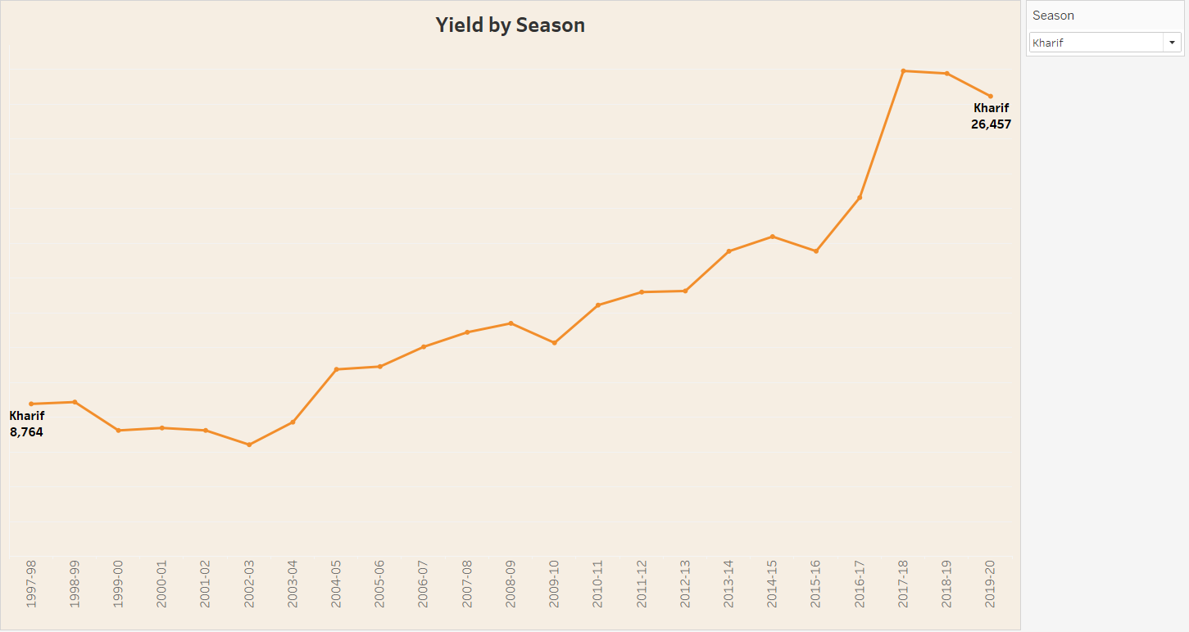

**3.5 Crop Plantation by Area**

Plantations, centred on a plantation house, grow crops including cotton, cannabis, coffee, tea, cocoa, sugar cane, opium, sisal, oil seeds, oil palms, fruits, rubber trees and forest trees. Perennial crops that are grown on a large scale by an individual or a company.

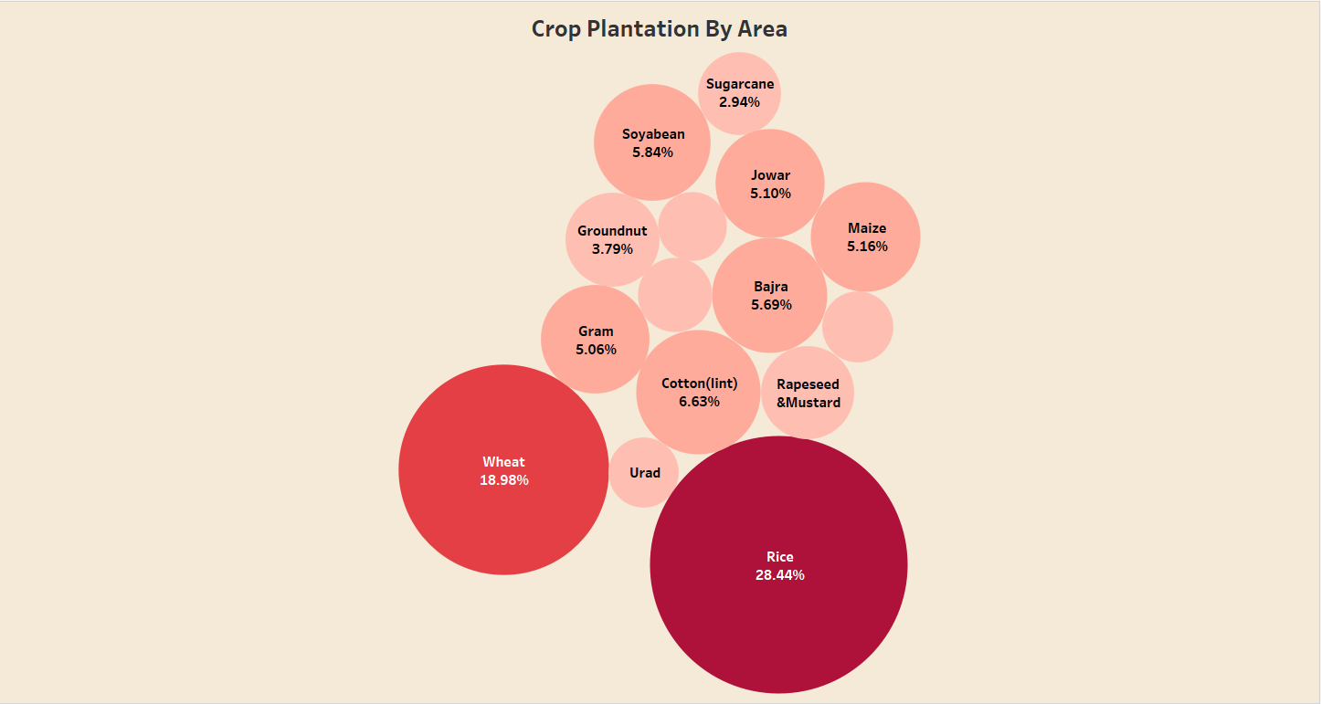

**3.6 Major Crops Growth Yoy**

Major crops grown in India are rice, wheat, millets, pulses, tea, coffee, sugarcane, oil seeds, cotton and jute, etc. of canal irrigation and tubewells have made it possible to grow rice in areas of less rainfall such as Punjab, Haryana and western Uttar Pradesh and parts of Rajasthan.

Rice is the most cultivated crop in India. India is the world's second-largest producer of rice.

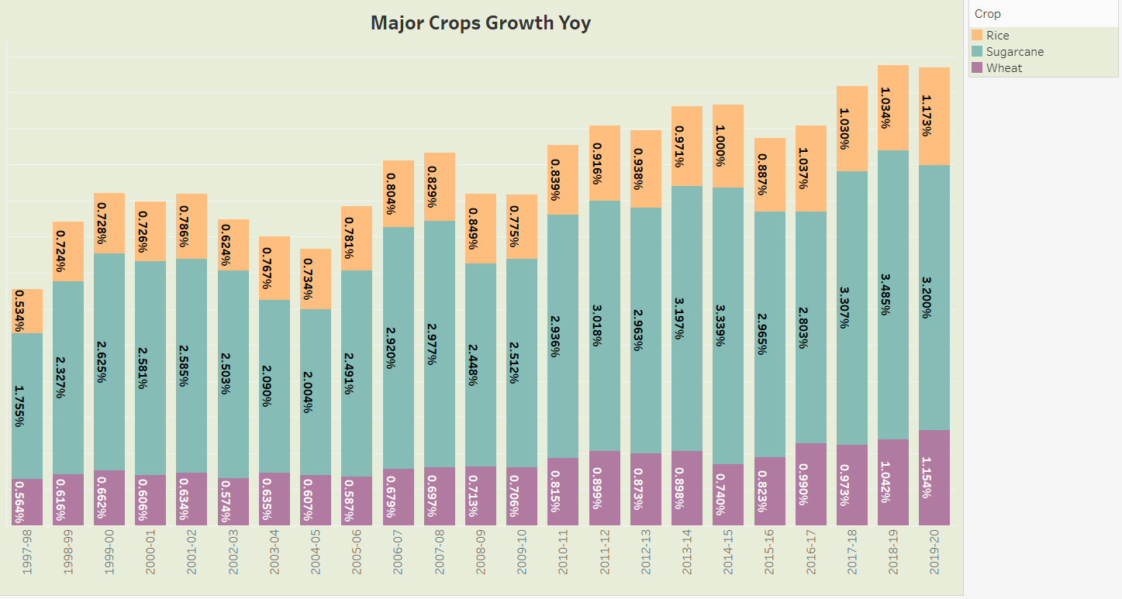

**3.7 Crops Plantation by Count**

Accurately mapping croplands is an important prerequisite for precision farming since it assists in field management, yield-prediction, and environmental management. Crops are sensitive to planting patterns and some have a limited capacity to compensate for gaps within a row.

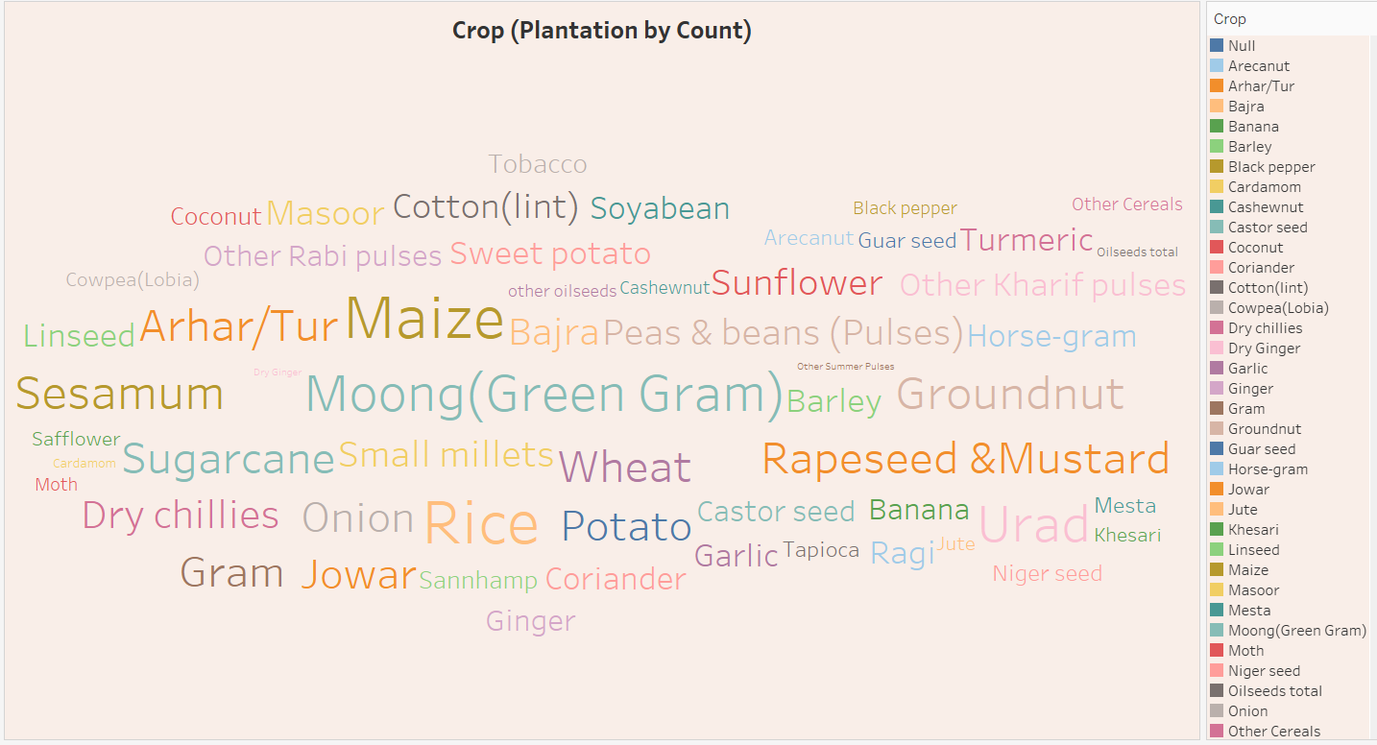

**3.8 Season wise Production**

Green gram, jowar, bajra, ragi, maize, groundnut, sunflower, and sesamum are some of the major summer crops. India has three cropping seasons -- summer, kharif, and rabi.

Rabi crops, which are also known as winter crops, are grown in the winter season. Some of the main rabi crops of India include wheat, barley, potato, mustard, chickpea, sunflower, etc.

In India, the season is popularly considered to start in June and end in October. Kharif crops are usually sown at the beginning of the first rains during the advent of the south-west monsoon season, and they are harvested at the end of monsoon season (October–November).

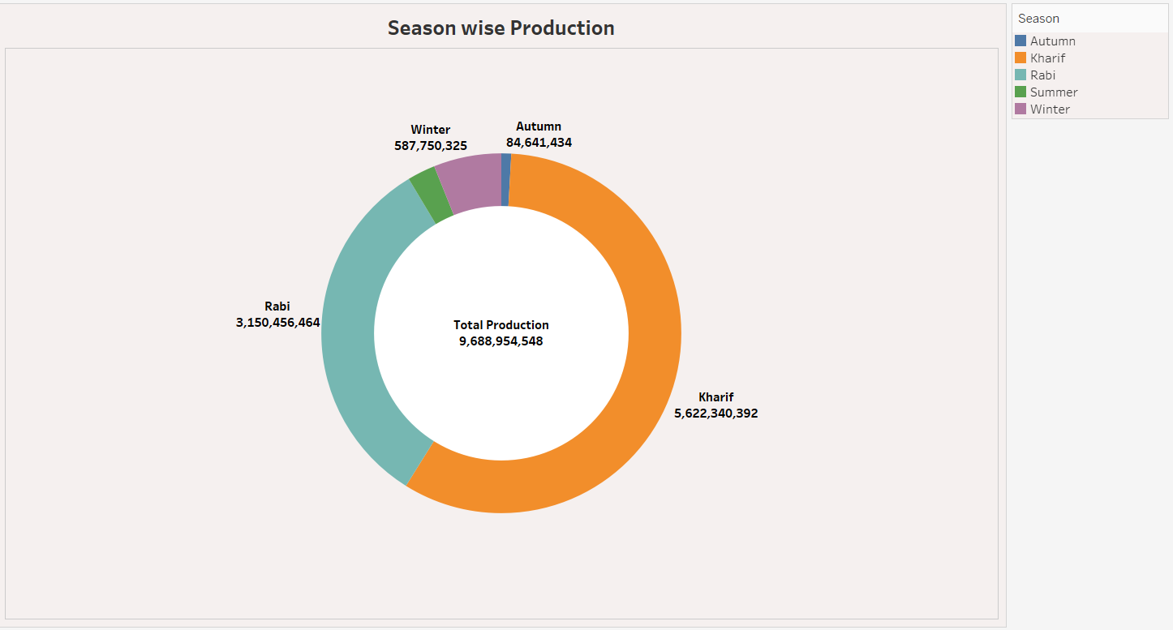

**3.9 Dashboard**

A dashboard is a graphical user interface (GUI) that displays information and data in an organized, easy-to-read format. Dashboards are often used to provide real-time monitoring and analysis of data and are typically designed for a specific purpose or use case. Dashboards can be used in a variety of settings, such as business, finance, manufacturing, healthcare, and many other industries. They can be used to track key performance indicators (KPIs), monitor performance metrics, and display data in the form of charts, graphs, and tables.

**3.9.1 Dashboard 1**

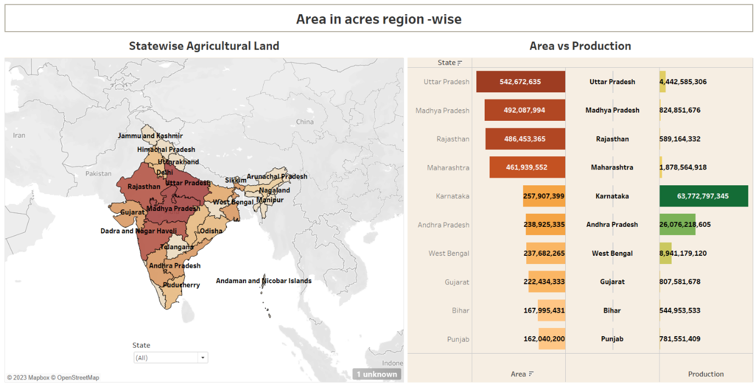

**3.9.2 Dashboard 2**

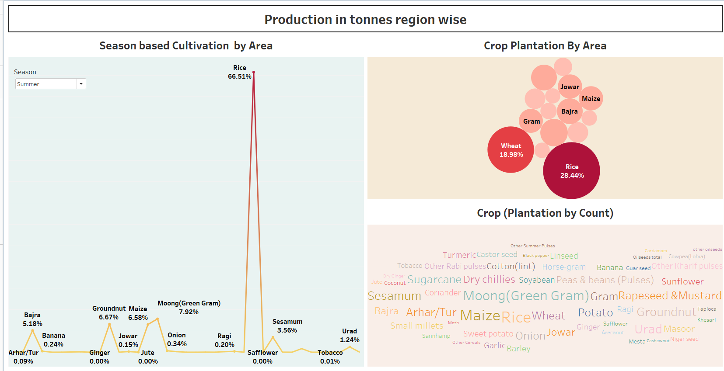

**3.9.3 Dashboard 3**

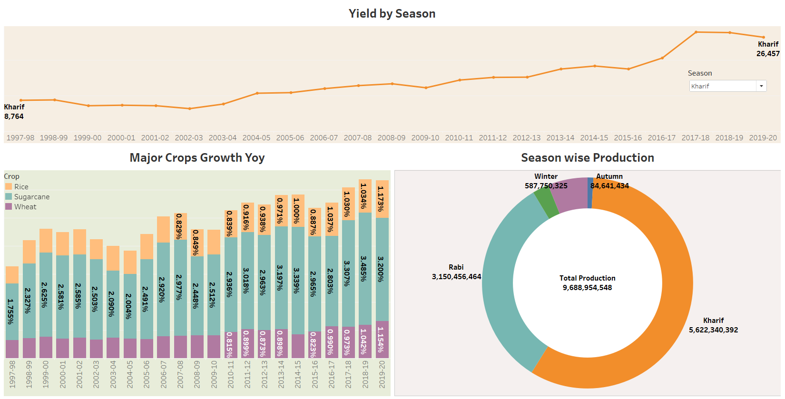

**3.10 Story**

A data story is a way of presenting data and analysis in a narrative format, intending to make the information more engaging and easier to understand. A data story typically includes a clear introduction that sets the stage and explains the context for the data, a body that presents the data and analysis logically and systematically, and a conclusion that summarizes the key findings and highlights their implications. Data stories can be told using a variety of mediums, such as reports, presentations, interactive visualizations, and videos.

The number of scenes in a storyboard for a data visualization analysis of the performance of banks will depend on the complexity of the analysis and the specific insights that are trying to be conveyed. A storyboard is a visual representation of the data analysis process and it breaks down the analysis into a series of steps or scenes.

**3.10.1 Story 1**

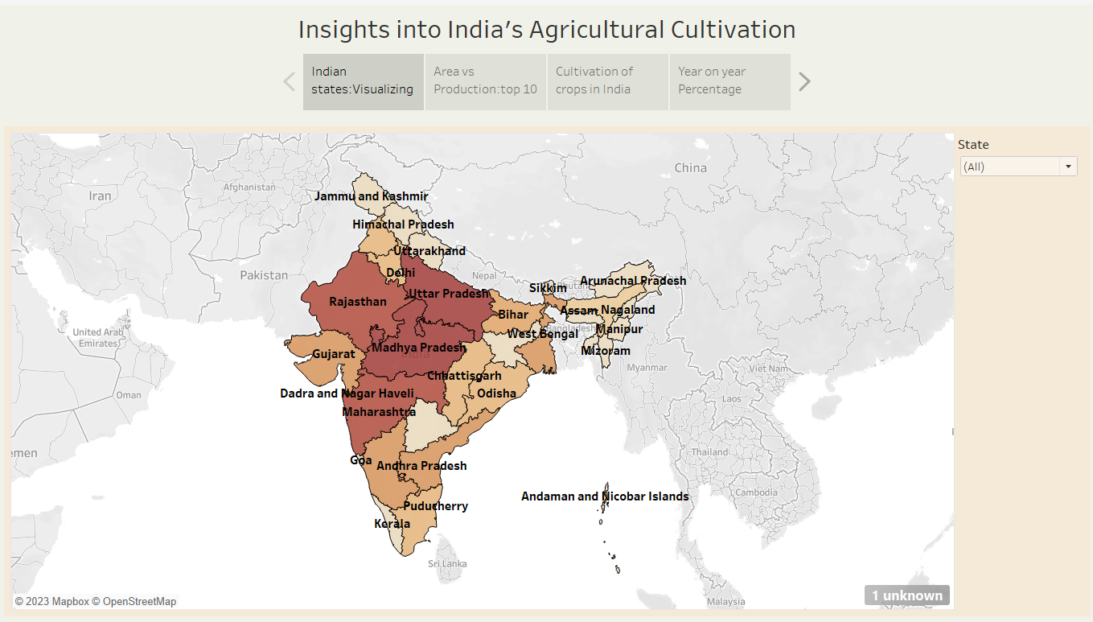

**3.10.2 Story 2**

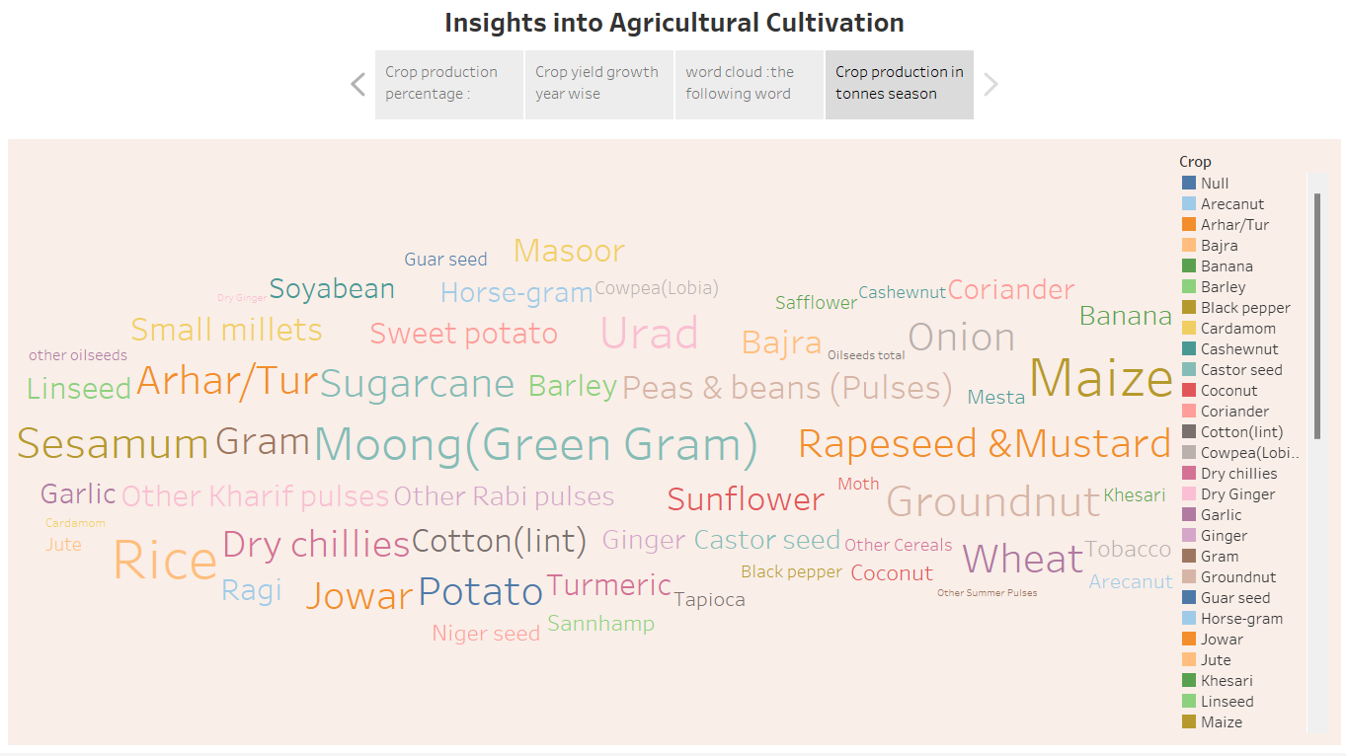

# **4. Advantages and Disadvantages**

**4.1 Advantages of Crop production**

A careful crop rotation holds the potential to bring a wide range of benefits. We have come up with a list of the most common ones.

**4.1.1 Increases the yielding capacity of the crops**

Crop rotation boosts the yield from just one seasonal harvest. Because several crop varieties are used, one receives a general bountiful harvest each season in addition to a variety of crops. Scientific research shows that crop rotation, as opposed to monoculture, increases crop output by 10% to 25%.

**4.1.2 The balance of nitrogen is maintained**

One of the essential elements for plant development is nitrogen. It is a crucial component of DNA, a protein's building block, and even chlorophyll. Even though 78 percent of the nitrogen in the atmosphere is in the form that plants can use. They require a sort of "fixed" nitrogen from the soil, such as ammonia, nitrate, or nitrite.

**4.1.3. Improves the soil structure**

Good crop growth depends on the condition of the soil. It has an impact on how easily water, air, and nutrients can reach the roots as well as how much room they must spread in the soil.

**4.1.4. Crop rotations ensure water conservation**

Crop rotation increases soils' ability to hold water when combined with better soil structure. Due to the alternation of deep and shallow-rooted plants during crop rotation on the same piece of land, the soil structure is improved.

**4.2 Disadvantages of Crop Production**

**4.2.1. Difficult to specify**

Every season, a different crop must be planted to ensure the success of crop rotation. Due to possible effects on the soil, the farmer might not be able to grow a single crop on a large scale for an extended period.

**4.2.2. Not appropriate in certain conditions**

Crop rotation may not be recommended in some temperatures and geographical areas.

In that area, monoculture may be favored because some crops may not do well in certain types of soils and climates.

**4.2.3. Improper implementation may lead to more harm than good**

When this approach is used incorrectly, more harm than good results. There is no reason to experiment if one lacks the technical knowledge of crop rotation because there could be nutrient build-up that would take longer to fix. However, information on the various planting methods is readily available, so the farmer should exercise caution and be prepared to use them as needed.

**5.Application**

* Supporting livelihoods through food, habitat, and jobs; providing raw materials for food and other products; and building strong economies through trade.
* It provides employment opportunity to the rural agricultural as well as non-agricultural labourers.
* It is efficient in mapping, monitoring, and managing farming decisions precisely. Agriculture solutions come in various formats such as satellite imagery, sensors, agriculture machines, and software solutions.
* Agriculture is the foundation of many economies around the world, and it is critical to feeding the world's growing population.

**6.Conclusion**

* Crop rotation could aid in the fight against the environment's pervasive chemical contamination. Consequently, the technique is advantageous to our health and may be one approach to preserving our food security while limiting the adverse consequences of agriculture on ecosystems.
* But all these benefits are possible only when you do it in the right manner. You need to select the right kind of crop and optimize the process. With the right technique and process, crop rotation can do wonders for farmers.

**7.Future Scope**

* Indian agriculture can help the nation tackle three of its biggest challenges it feeding a huge and expanding population, ensuring sufficient energy supplies and curbing emissions. Still, meeting these goals will require a coordinated effort with alignment across policy, investment and agricultural research.
* Due to globalisation, increase in household incomes and health consciousness the demand for fruits and vegetables, dairy products, fish and meat is going to increase in future. Research, technology improvements, protected cultivation of high-value greens and other vegetables will be more.
* The agricultural sector accounts for 15% of India's export earnings and 14-17% of GDP. The agricultural sector provides raw materials for a variety of industries, including textiles, sugar, flour mills, jute, and apparel.
* Agriculture is good for the future as it is expected to use advanced technologies and innovations to produce more food with limited land and resources, increase efficiency on farms, and become more profitable, efficient, safe, and environment friendly.
* Agriculture is an essential industry that provides the food that we eat. As the global population continues to grow, the demand for food will only increase. By pursuing a career in agriculture, you will be playing a crucial role in feeding people all over the world.